**Pactera home page automation test**

**1.Purpose:**

This document provides information about how to drive pactera Home page test automation script

2.**Introduction:**

This project opens the firefox browser and navigates to the url of pactera home page and searches for the key word and displays the results of searched keyword page.

3. **Pre-Requisites:**

* Maven
* Jdk
* Mozilla firefox browser

**4.How to Run project:**

1. Ensure java is installed in your machine and set path has been set, if not follow as step 2 to set path
2. Click **Start**, then **Control Panel**, then **System**.-🡪 Click **Advanced**, then **Environment Variables**-🡪 Add the location of the bin folder of the JDK installation for the PATH variable in **System Variables**. The following is a typical value for the PATH variable:
3. C:\WINDOWS\system32;C:\WINDOWS;**C:\Program Files\Java\jdk1.7.0\bin**
4. Copy the *apache-maven-3.2.5*  directory to your local drive where you wish to install Maven 3.2.5. These instructions assume you chose *C:\Program Files\Apache Software Foundation*. The subdirectory apache-maven-3.2.5 will be created from the archive.
5. Add the unpacked distribution's bin directory to your user *PATH* environment variable by opening up the system properties selecting the "Advanced" tab, and the "Environment Variables" button, then adding or selecting the *PATH* variable in the user variables with the value **C:\Program Files\Apache Software Foundation\apache-maven-3.2.5\bin.**
6. **Optional**: In the same dialog, add the MAVEN_OPTS environment variable in the user variables to specify JVM properties, e.g. the value -Xms256m -Xmx512m. This environment variable can be used to supply extra options to Maven.
7. In the same dialog, make sure that **JAVA_HOME** exists in your user variables or in the system variables and it is set to the location of your JDK, e.g. **C:\Program Files\Java\jdk1.7.0_51.**
8. Open a *new* command prompt (Winkey + R then type cmd) and run mvn --version to verify that it is correctly installed.

Note: if every thing installed and perfectly set up you can see as below screen shot provided in your command prompt.

Url for Jdk download: <http://www.oracle.com/technetwork/java/javase/downloads/jdk8-downloads-2133151.html>

url for Mavne download: http://maven.apache.org/download.cgi

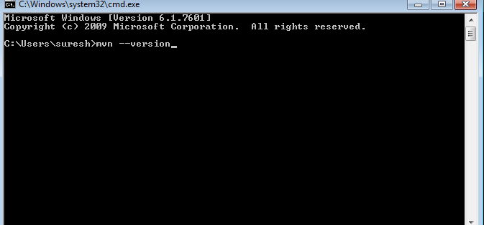

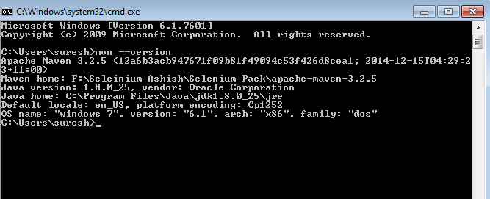

Pic: if Maven installed correctly.

1. Now change the directory where you saved the project from the url provided, for example I have saved the project in f:/PacteraHomePageTest then In command prompt changed my directory to f:/ PacteraHomePageTest

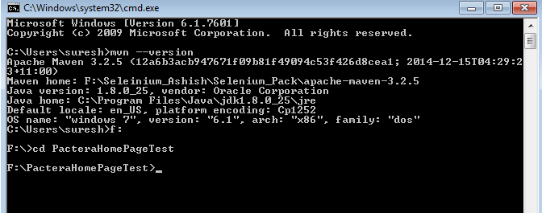

Fig.B: showing changed the directory where the project is saved

10.Now type mvn clean install as shown in the below screen shot 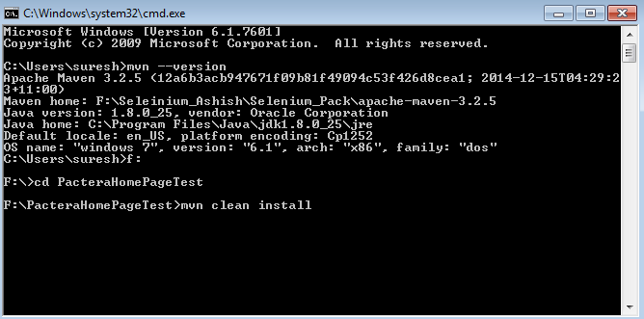

Fig.C: command to run the project

11.then project start running and at the end you see the message as Build success as below screenshot

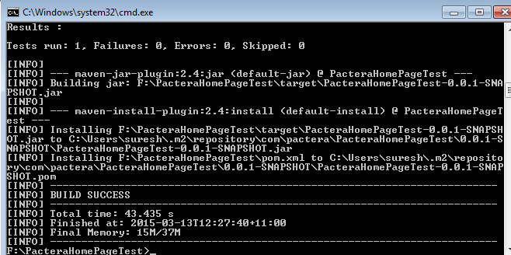

Fig.D: Screen shot displaying build success.

12.for screen shots That are captured during runtime will be saved under Project directory ie: .\PacteraHomePageTest\ScreenShots where you can find screen shots as below

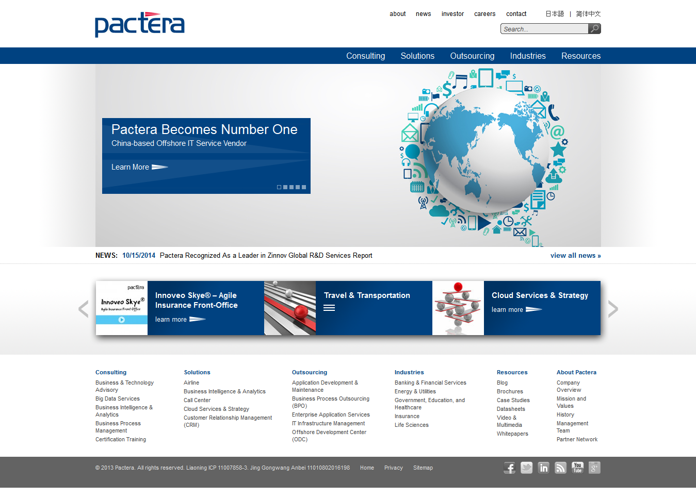

Fig.E. Screen shot of Pactera home page captured during runtime

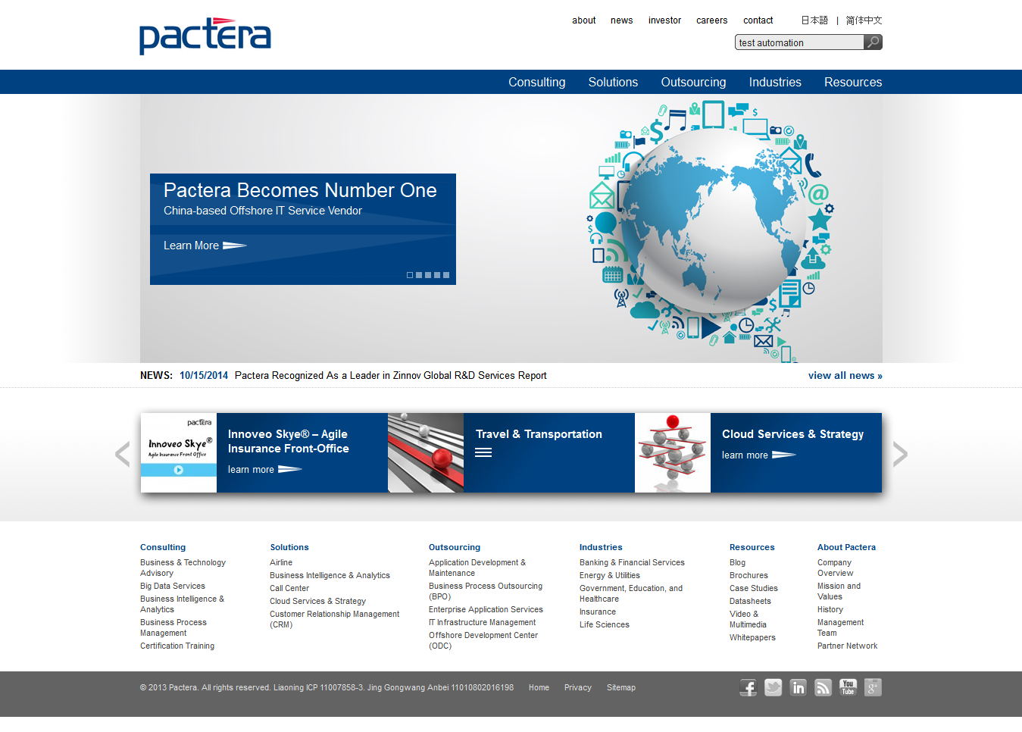

Fig.F: Screen shot after entering key word test automation

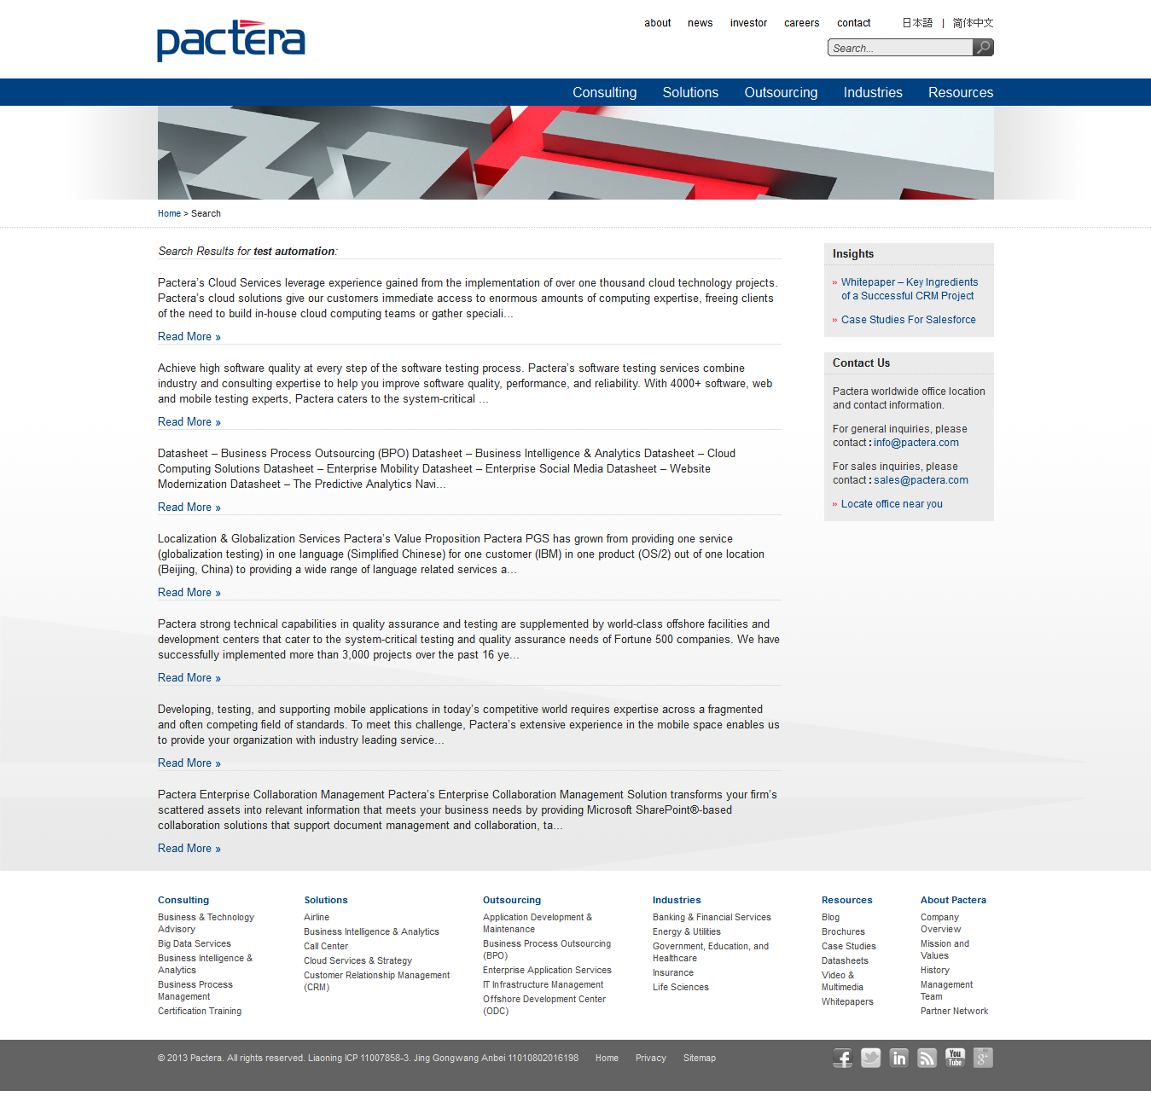

Fig.G: Screen shot for resultpage

13. To find the logs that are captured during runtime goto path: .\PacteraHomePageTest\Logs, you find the log file with name Pactera.log, it contains log detail as below screen shot

